Sports & Social Club July 2026 – Postal Edition

Request for email address
If you currently receive our newsletter by post, please do share your email with us so we can deliver updates straight to your inbox. It’s faster, easier, reduces our paper use, and helps us stay connected with you.
You can provide your email by contacting us at social_club@bathnes.gov.uk
or by calling 01225 394041.

🎄Stourhead Christmas Lights 🎄
We’re spreading some festive cheer with an exclusive offer for members of the Bath and North East Somerset Social Club!
If you book tickets to the Stourhead Christmas Lights for any date between 27th November and 3rd January, we’ll refund £20 of your total ticket cost.
How to Claim Your £20 Refund:
- Book your tickets via the official site: https://premier.ticketek.co.uk/shows/show.aspx?sh=CSTXMAS26
- Complete the Social Club form: https://forms.office.com/e/qFA6Cs9cP3
- Please email us:
-A copy of your invoice
-Your preferred bank details for the refund
We’ll process your £20 refund in January and send it directly to your nominated bank account.
Important Notes:
- This offer is limited to one refund per member irrespective if multiple members attend via one booking (Maximum refund is £20)
The first 20 will receive this offer, please feel free to check and we may close the offer early if this maximum is reached


October 2026 BETTER Gym Membership

The Bath and North East Somerset Council Sports Social club has agreed another great offer with BETTER gyms.
As a sports and social club member you can have a 12-month Better Health Corporate Partnership membership from 1st October 2026 at an up-front rate of £346/person/year for the Social Club Member only (Friends and Family continue to pay £366).
We have been able to work with GLL to keep the prices low and as a committee we are able to supplement the membership by a further £20 for 1st October 2026, we will keep this under regular review and would hope that we can continue this throughout the next cycles of membership in Jan, April and July to ensure fairness for memberships taken in 2026. Notwithstanding the increase in price in April. This applies to the Member only.
Gym members can also nominate two friends and/or family members not living at the same address for the Friends and Family discounted price of £366.
You will have full access to Bath Sport and Leisure, Odd Down Sports Ground, and Keynsham Leisure Centre.
Membership Description (full terms and exclusions at www.better.org.uk/terms):
- Access to gym floor, including cardio, functional & weights
- Access to fitness swimming pools, spa pools, saunas and steam rooms
- Access to full fitness classes programme
- Online library of 1500+ on demand fitness classes and workouts
- Online Health library of eBooks and eAudio resources
- 6 week support programme with certified instructors
- 7 Day advanced booking online or via the Better UK app
- Up to 30% off other activities and services
To take up this offer, please complete this form:
https://forms.office.com/e/EsmtsV6jmi Closing Date 31st August 2026
Forms and/or payments received after this deadline will not be processed.
You must be a member of the social club for the entire year of the gym membership.
🎭 Theatre Shows 🎭
Booking forms available: https://www.bathnessocialclub.co.uk/theatre.php
 | **NEW SHOW** dinnerladies  Thursday 18th February 2027, 19:30  Theatre Royal Bath  More than 25 years after it first aired on BBC One, Victoria Wood's much-loved sitcom dinnerladies is heading to the stage, in the first piece of Victoria’s work to be produced by her estate.  Members: £34.60  Non-Members First Guest: £34.60  Non-Members: £49.40  Closing Date: 1st August 2026
**NEW SHOW** A Thousand Splendid Suns  Thursday 4th March 2027, 19:30  Theatre Royal Bath  In 1992 in an Afghanistan ravaged by war, an orphaned Laila is left alone in an increasingly threatening world. Her older neighbour Rasheed is quick to open his home and takes Laila as his second wife.  Members: £31.00  Non-Members First Guest: £31.00  Non-Members: £44.40  Closing Date: 1st August 2026 |  |  | 
 | **NEW SHOW** Richard II  Thursday 22nd April 2027, 19:30  Theatre Royal Bath  A kingdom on a knife-edge. King Richard II (Freddie Fox) is a monarch of absolute power and divine right to rule. Easily swayed and badly advised, Richard plunges England into an ever-deepening crisis as his uncle, the Duke of York (Roger Allam) tries to rescue the country from disaster. But Richard's enemies are powerful, angry and out for revenge.  Members: £35.50  Non-Members First Guest: £35.50  Non-Members: £50.70  Closing Date: 1st August 2026
**NEW SHOW** Blood Brothers  Thursday 6th May 2027, 19:30  Theatre Royal Bath  Written by Willy Russell, the legendary Blood Brothers tells the captivating and moving tale of twins who, separated at birth, grow up on opposite sides of the tracks, only to meet again with fateful consequences.  Members: £38.60  Non-Members First Guest: £38.60  Non-Members: £55.20  Closing Date: 1st August 2026 |  |  |  | 
Members: £38  Non-Members First Guest: £38  Non-Members: £52.60  Closing Date: 30th August 2026 |  | **NEW SHOW** Pretty Woman  Wednesday 18th August 2027, 19:30  Bristol Hippodrome  It’s time to head to Beverly Hills and experience one of Hollywood’s most iconic romantic comedies of all time. This ‘dazzling new stage show’ (Daily Express) takes to the road again in 2027 following a record-breaking run in the West End and a sell-out first UK tour in 2023.  Age guidance: 12+ Contains some moderate sexual references

🎭 Theatre Shows 🎭
Booking forms available: https://www.bathnessocialclub.co.uk/theatre.php
Sleeping Beauty EXTENDED DATE  Sunday 20th December 2026, 13:00  Bristol Hippodrome  Starring Craig Revel Horwood as the wicked Carabosse and Bristol panto favourite Andy Ford as Muddles!  Once upon a time in a faraway kingdom, Princess Aurora receives a birthday present from her wicked aunt Carabosse. A single prick of an enchanted spinning wheel places her under a cruel curse and sends her into a century of slumber!  Will true love endure? Will The Prince to break the spell? Who Come and find out in a panto packed with magic, music, comedy and dazzling special effects! | 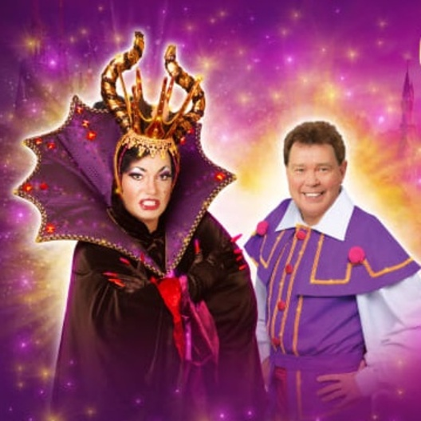  Members: £33  Non-Members First Guest: £33  Non-Members: £46  Children: £33  Closing Date: 21st August 2026  EXTENDED DATE

Beauty and the Beast  Saturday 2nd January 2027, 14:00  Theatre Royal Bath  Starring Jon Monie as the hilarious Louis La Plonk!  This glittering festive extravaganza promises breath-taking sets, glittering costumes and sensational choreography – all wrapped up in a magical story filled with laughter, romance and wonder. | 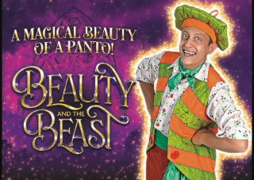  Members: £29  Non-Members First Guest: £29  Non-Members: £41  Children: £29  Closing Date: 22nd August 2026

🏷️ Local Offers 🏷️
Komedia Comedy Club  20% discount  On standard auditorium or balcony seats (not including Meal Deal options) for Komedia Comedy Club Saturdays using code: B&N4BDD at booking. This also includes free entry to The Big Disco or Motorcity afterwards!  22-23 Westgate St, Bath BA1 1EP  https://komediabath.co.uk/ | 

Little Theatre  25% discount  On annual membership  St Michael's Pl, Bath BA1 1SF  https://www.picturehouses.com/cinema/little-theatre-cinema | 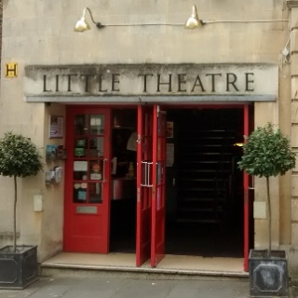

Bath Aqua Glass  15% discount  On in store items  14 Cheap Street / 15 Abbey Churchyard,  Bath, Somerset, BA1 1NA  https://www.bathaquaglass.com/ | 

Boom Battle Bar Bath  15% discount  on all drinks and games in store  Kingsmead Leisure Complex,  5-10 James Street West, Bath BA1 2BX  boombattlebar.com | 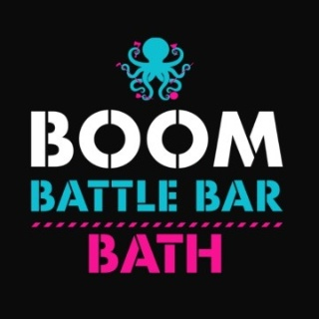

⛹️‍♂️ Sports ⛹️‍♂️
https://www.bathnessocialclub.co.uk/take-part-in-sports.php
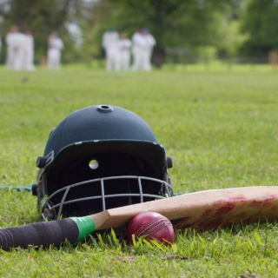 | Cricket Club  The Cricket Club organise matches over the summer and welcome players of all standards. The club plays 20-over matches in the evenings from the end of April to the beginning of August. It is a mixed-ability team that plays 'social' cricket in and around the city of Bath. They also try and organise pre-season cricket nets.  If you are interested in becoming a player or would like to umpire or score please email tom_deller@bathnes.gov.uk

 | Five-a-Side Football at Keynsham Leisure Centre  Come and join us for a friendly game of five-a-side football!  Played on Tuesdays from 12:00 - 13:00  £4 for members, £5.50 non-members.  To be added to the player list please email: robin_spalding@bathnes.gov.uk

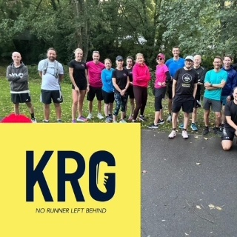 | NEW Keynsham Running Club  Meet us every Wednesday at 12:15pm outside Wild About Flowers for a relaxed and friendly 5km run around Keynsham with an optional brew at the end.  We welcome all abilities - whether you're new to running, returning after a break, or a seasoned runner. Our motto is “No runner left behind” and we mean it! And it’s free.

🏆 Social Club Committee 🏆
 | Join the team!  We are run entirely by volunteers and we need more wonderful people to help us in planning and organising new events. Can you spare a couple of hours a month?  Please email us and we can invite you to our next meeting😊
Website: https://www.bathnessocialclub.co.uk/ Email: social_club@bathnes.gov.uk

