


Theatre Royal – Bath
Present Laughter – Thursday 3rd Sept 19:30
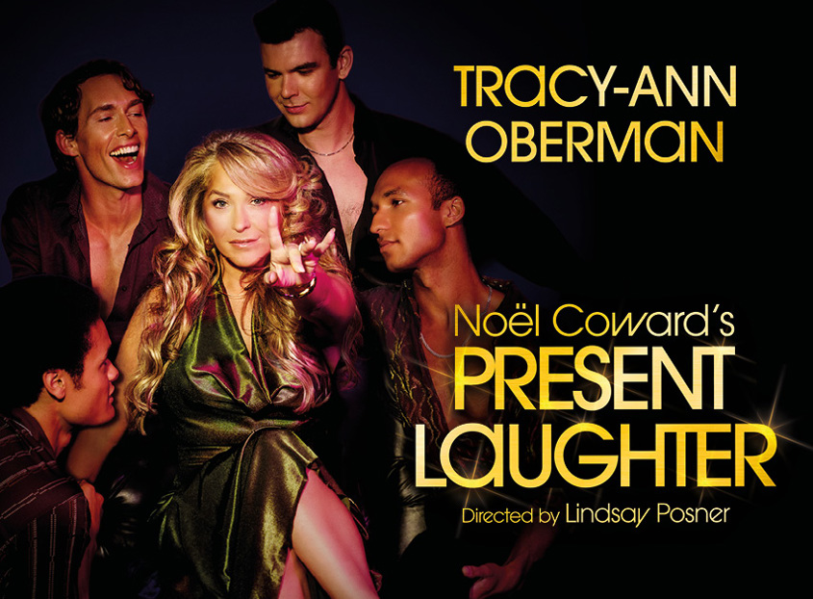
Geri Essendine is a hugely successful actress who has been 39 for the best part of a decade. Her personality, wit and charm have earned her a legion of devoted fans, young and old, and a coterie of friends, acquaintances and hangers-on.
Members: £37.00 First Non-members: £37.00 Other Non-members £53.00
CLOSING DATE: 13th March 2026
TO pay –
Email your booking form to social_club@bathnes.gov.uk and pay via –
Bank transfer: HSBC, sort code - 400944, account no - 20121282, account name -B&NES Social Club - Please use Laughter as the reference, plus your initials.
By post: PERSONAL/Theatre Royal
Sue Boulton/ Kellie Farnham c/o Post Room,
Lewis House, Manvers Street, Bath, BA1 1JG
Cheque: payable to B&NES Social Club. The sports and social club are now charged 40p per cheque we pay in, please pay via bank transfer wherever possible.

If you pay by bank transfer please submit your booking form showing the tickets you want – and make the bank transfer. We will only contact you if there is a problem.
Please do not request specific seats – all seats are allocated on a ‘first come, first served’ basis and are dependent on what seats the Theatre is able to allocate.
Bookings are accepted on the strict understanding that the social club is unable to refund monies already paid to the Theatre Royal unless the Club is reimbursed by the Theatre Royal.

Please provide up-to-date email address/telephone number as this makes it easier for us to contact you. All tickets will be sent near to the Showtime via email, if you would like your tickets posted please request this.

Bath Theatre Royal – Present Laughter

Date: Tuesday 3rd Sept 2026 – 19:30

I wish to reserve ___________ seats in total for Present Laughter
----------- Members @ £37.00 =
----------- First Non-member @ £37.00 =
----------- Non-members @ £53.00 =
Tick here to confirm you have paid via bank transfer ____________total
transferred________________ date transferred__________________
Bank transfer: HSBC, sort code - 400944, account no - 20121282, account name -B&NES Social Club - Please use Laughter as the reference plus your initials.
OR

Cheque for £_______________ included – Please note the sports and social club are now charged 40p per cheque we pay in, please pay via bank transfer wherever possible.

Name(s): …………… ……………………………………………………………………

Membership Number(s) …………………………………………………………………

(Name and Membership Number must be quoted for each member attending)

Home Address: (please complete - if we can’t send you your tickets by email)

………………………………………………………………………………………………

….……………………………………………………………………………………………

Tel: ………………………………… Email: ……………………………………………..

Bank transfer is our preferred payment method however if you are unable to pay this way, cheques should be made payable to ‘B&NES Social Club’ and sent in an envelope marked ‘Personal/Bath Theatre Royal to Sue Boulton/Kellie Farnham C/O Post Room, Lewis House, Manvers Street, Bath BA1 1JG. Please do not enclose cash.

Closing Date: 13th March 2026

