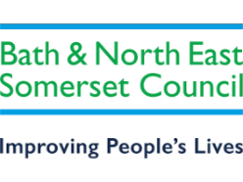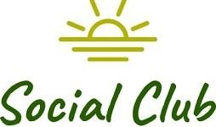

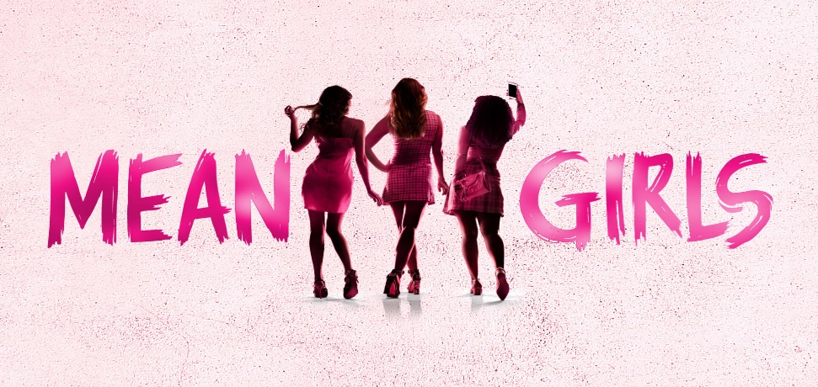

**Thursday 10th September 2026 – 19:30**

**Meet The Plastics – Regina, Gretchen and Karen. They rule North Shore High and will burn anyone who gets in their way. Home-schooled Cady Heron may think she knows a thing or two about survival of the fittest thanks to her zoologist parents, but high school is a whole new level of savage. When Cady devises a plan to end Regina’s reign, she learns the hard way that you can’t cross a queen bee without getting stung.**

**We have reserved 60 stalls seats for the above date.**

To pay –

Email your booking form to [social_club@bathnes.gov.uk](mailto:social_club@bathnes.gov.uk) and pay via –

**Bank transfer:** HSBC, sort code - 400944, account no - 20121282, account name -B&NES Social Club - Please use **Mean Girls** as the reference, plus your initials.

OR

By post: PERSONAL/Bristol Hippodrome

Marie Bushby c/o Post Room,

Lewis House, Manvers Street, Bath, BA1 1JG

**Cheque:** payable to B&NES Social Club. The sports and social club are now charged 40p per cheque we pay in, **please pay via bank transfer** wherever possible.

If you pay by bank transfer please submit your booking form showing the tickets you want – andmake the bank transfer. *We will only contact you if there is a problem.*

**Please do not request specific seats** – all seats are allocated on a ‘first come, first served’ basis and are dependent on what seats the Theatre is able to allocate.

Bookings are accepted on the strict understanding that the social club is unable to refund monies already paid to the hippodrome unless the Club is reimbursed by the Bristol Hippodrome.

Please provide up-to-date email address/telephone number as this makes it easier for us to contact you. **All tickets will be sent near to the Showtime via email, if you would like your tickets posted please request this.**

***CLOSING DATE – Friday 16th January 2026***

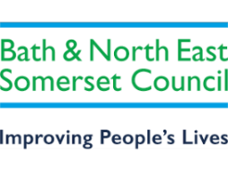

**Bristol Hippodrome – Mean Girls**

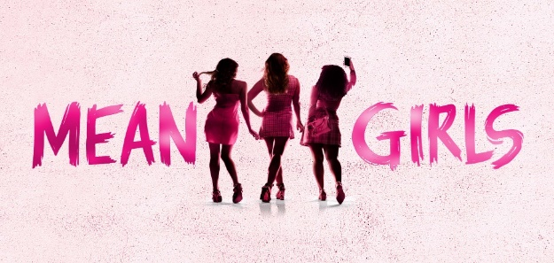

**Thursday 10th September 2026 – 19:30**

I wish to reserve ___________ seats in total for Mean Girls

----------- Members **@ £47.00**

**------------ Members plus one £47.00**

----------- Non-members **@ £59.00**

**Tick here to confirm you have paid via bank transfer ____________total transferred________________ date transferred__________________?**

**Bank transfer:** HSBC, sort code - 400944, account no - 20121282, account name -B&NES Social Club - Please use **Mean Girls** as the reference plus your initials.

**OR**

**Cheque for £_______________ included –** *Please note the sports and social club are now charged 40p per cheque we pay in, please pay via bank transfer wherever possible.*

Name(s): …………… ……………………………………………………………………

Membership Number(s) …………………………………………………………………

**(Name and Membership Number must be quoted for each member attending)**

Home Address: (please complete - if we can’t send you your tickets by email)

………………………………………………………………………………………………….

…………………………………………………………………………………………………. Tel: ………………………………… Email: …………………………………………………

Bank transfer is our preferred payment method however if you are unable to pay this way, cheques should be made payable to **‘B&NES Social Club’** and sent in an envelope marked ‘Personal/Bristol Hippodrome’ to Marie Bushby**,** C/O Post Room, Lewis House, Manvers Street, Bath BA1 1JG. ***Please do not enclose cash.***

***CLOSING DATE – Friday 16th January 2026***