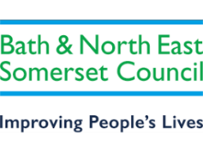


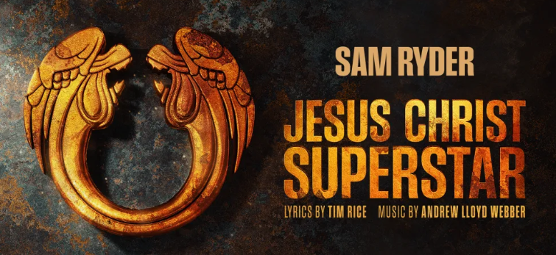

Wednesday, 27 October 2027– 19:30

Tim Rice and Andrew Lloyd Webber’s Jesus Christ Superstar follows the events of the last days of the life of Jesus Christ, as seen through the eyes of Judas. Reflecting the rock roots that defined a generation, the legendary score includes ‘I Don’t Know How to Love Him’, ‘Gethsemane’ and the iconic title number ‘Superstar’.
Age guidance 10+. Under 16s must be accompanied by an adult 18+. No under 3s allowed. Contains flashing lights and visual effects, pyrotechnics, theatrical smoke and haze, some violence, imitation blood, and an onstage depiction of the crucifixion.
We have reserved 40 stalls seats for the above date.
To pay –
Email your booking form to social_club@bathnes.gov.uk and pay via –

Bank transfer: HSBC, sort code - 400944, account no - 20121282, account name -B&NES Social Club - Please use JCS as the reference, plus your initials.

OR
By post: PERSONAL/Bristol Hippodrome
Marie Bushby c/o Post Room,
Lewis House, Manvers Street, Bath, BA1 1JG

Cheque: payable to B&NES Social Club. The sports and social club are now charged 40p per cheque we pay in, please pay via bank transfer wherever possible.

If you pay by bank transfer please submit your booking form showing the tickets you want – and make the bank transfer. We will only contact you if there is a problem.

Please do not request specific seats – all seats are allocated on a ‘first come, first served’ basis and are dependent on what seats the Theatre is able to allocate.
Bookings are accepted on the strict understanding that the social club is unable to refund monies already paid to the hippodrome unless the Club is reimbursed by the Bristol Hippodrome.

Please provide up-to-date email address/telephone number as this makes it easier for us to contact you. All tickets will be sent near to the Showtime via email, if you would like your tickets posted please request this.

CLOSING DATE – 31st December 2026

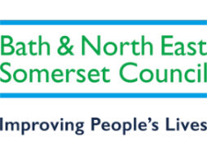

Bristol Hippodrome – Jesus Christ Superstar

Wednesday, 27 October 2027– 19:30

I wish to reserve ___________ seats in total for Jesus Christ Superstar
----------- Members @ £42.00 (Saving of £40.60) 40% off the full price
------------ Members plus one £42.00 (Saving of £40.60) 40% off the full price
----------- Non-members @ £69.00 (This is a group discount; normal price is £82.60)
Tick here to confirm you have paid via bank transfer ____________total transferred________________ date transferred__________________?

Bank transfer: HSBC, sort code - 400944, account no - 20121282, account name -B&NES Social Club - Please use JCS as the reference plus your initials.

OR

Cheque for £_______________ included – Please note the sports and social club are now charged 40p per cheque we pay in, please pay via bank transfer wherever possible.

Name(s): …………… ……………………………………………………………………

Membership Number(s) …………………………………………………………………

(Name and Membership Number must be quoted for each member attending)

Home Address: (please complete - if we can’t send you your tickets by email)

………………………………………………………………………………………………….

…………………………………………………………………………………………………. Tel: ………………………………… Email: …………………………………………………
Bank transfer is our preferred payment method however if you are unable to pay this way, cheques should be made payable to ‘B&NES Social Club’ and sent in an envelope marked ‘Personal/Bristol Hippodrome’ to Marie Bushby, C/O Post Room, Lewis House, Manvers Street, Bath BA1 1JG. Please do not enclose cash.
CLOSING DATE – 31st December 2026

