How to check your GLL membership expiry date
Click My Account
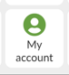
Click My Memberships

Membership start and end dates are shown
