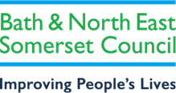
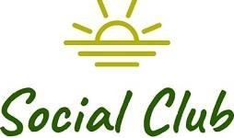

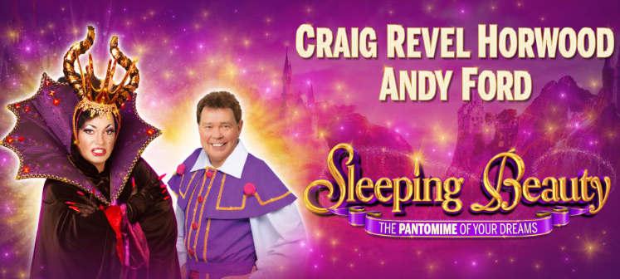
BRISTOL HIPPODROME
Sleeping Beauty (Pantomime)
Sunday, 20 December 2026 at 13:00 (1:00pm)
We have 100 seats Grand Circle and stalls (first come first served).

Once upon a time in a faraway kingdom, Princess Aurora receives a birthday present from her wicked aunt Carabosse. A single prick of an enchanted spinning wheel places her under a cruel curse and sends her into a century of slumber!
Will true love endure? Will The Prince to break the spell? Who Come and find out in a panto packed with magic, music, comedy and dazzling special effects!

To pay –
Email your booking form to social_club@bathnes.gov.uk and pay via –

Bank transfer: HSBC, sort code - 400944, account no - 20121282, account name -B&NES Social Club - Please use Sleeping Beauty as the reference, plus your initials

Or By post: PERSONAL/Bristol Hippodrome
Marie Bushby c/o Post Room,
Lewis House, Manvers Street, Bath, BA1 1JG
Cheque: payable to B&NES Social Club. The sports and social club are now charged 40p per cheque we pay in, please pay via bank transfer wherever possible.

If you pay by bank transfer please submit your booking form showing the tickets you want – and make the bank transfer. We will only contact you if there is a problem.

Please do not request specific seats – all seats are allocated on a ‘first come, first served’ basis and are dependent on what seats the Theatre is able to allocate.
Bookings are accepted on the strict understanding that the social club is unable to refund monies already paid to the hippodrome unless the Club is reimbursed by the Bristol Hippodrome.

Please provide up-to-date email address/telephone number as this makes it easier for us to contact you. Please give your home address if we can’t send you your tickets by email.
CLOSING DATE – 22nd May 2026
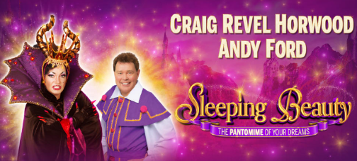

Bristol Hippodrome PANTO – Sleeping Beauty

Sunday 20th December 2026 at 13.00 (1:00pm)

I wish to reserve ___________ seats for Sleeping Beauty in total.
----------- Members @ £33.00 (30% off the ticket price – saving £13.00)
----------- Non-Members first guest (one per member) @ £33.00 (30% off the ticket price – saving £13.00)
----------- Non-members @ £46.00
----------- Children @ £33.00 (30% off the ticket price – saving £13.00)
Tick here confirms you have paid via bank transfer _____total transferred_________ date transferred__________________?

Bank transfer: HSBC, sort code - 400944, account no - 20121282, account name -B&NES Social Club - Please use Sleeping Beauty as the reference plus your initials.

OR

Cheque for £_______________ included – Please note the sports and social club are now charged 40p per cheque we pay in, please pay via bank transfer wherever possible.

Name(s): …………… ……………………………………………………………………

Membership Number(s) …………………………………………………………………

(Name and Membership Number must be quoted for each member attending)

Home Address: (please complete - if we can’t send you your tickets by email)

………………………………………………………………………………………………….

Tel: ………………………………… Email: …………………………………………………
Bank transfer is our preferred payment method however if you are unable to pay this way, cheques should be made payable to ‘B&NES Social Club’ and sent in an envelope marked ‘Personal/Bristol Hippodrome’ to Marie Bushby, C/O Post Room, Lewis House, Manvers Street, Bath BA1 1JG. Please do not enclose cash.
CLOSING DATE – 22nd May 2026
E tickets are sent out a few weeks before the show

