


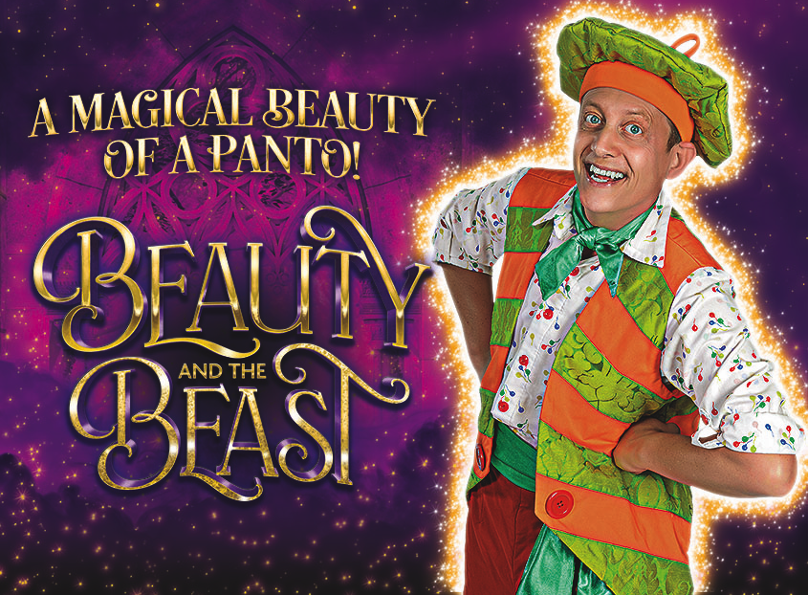
Theatre Royal – Bath
Saturday 2nd January 2027 at 14:00
We have 60 Stalls seat reserved (first come first served).

Beauty and the Beast is the festive spectacular everyone is talking about - the unmissable highlight of the Christmas season - thrilling, heart-warming and bursting with festive magic.

To pay –
Email your booking form to social_club@bathnes.gov.uk and pay via –

Bank transfer: HSBC, sort code - 400944, account no - 20121282, account name -B&NES Social Club - Please use Beauty as the reference, plus your initials

Or By post: PERSONAL/Theatre Royal
Sue Boulton/Kellie Farnham c/o Post Room,
Lewis House, Manvers Street, Bath, BA1 1JG
Cheque: payable to B&NES Social Club. The sports and social club are now charged 40p per cheque we pay in, please pay via bank transfer wherever possible.

If you pay by bank transfer please submit your booking form showing the tickets you want – and make the bank transfer. We will only contact you if there is a problem.

Please do not request specific seats – all seats are allocated on a ‘first come, first served’ basis and are dependent on what seats the Theatre is able to allocate.
Bookings are accepted on the strict understanding that the social club is unable to refund monies already paid to the Theatre Royal unless the Club is reimbursed by the Theatre Royal.

Please provide up-to-date email address/telephone number as this makes it easier for us to contact you. Please give your home address if we can’t send you your tickets by email.

CLOSING DATE - Friday 22nd August 2026

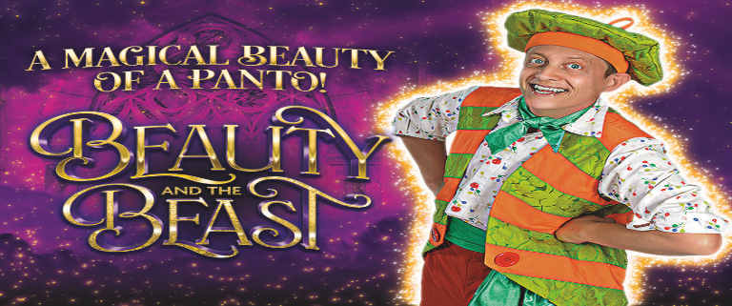

Theatre Royal Bath – Saturday 2nd Jan 2027 – 14:00

I wish to reserve __ Beauty and the Beast in total.
Members @ £29.00
Non-members @ £41.00
Children (under 16) @ £29.00
Tick here confirms you have paid via bank transfer _____total transferred £_________ date transferred__________________?

Bank transfer: HSBC, sort code - 400944, account no - 20121282, account name -B&NES Social Club - Please use Beauty as the reference plus your initials.

OR

Cheque for £_______________ included – Please note the sports and social club are now charged 40p per cheque we pay in, please pay via bank transfer wherever possible.

Name(s): …………… ……………………………………………………………………

Membership Number(s) …………………………………………………………………

(Name and Membership Number must be quoted for each member attending)

Home Address: (please complete - if we can’t send you your tickets by email)

………………………………………………………………………………………………….

Tel: ………………………………… Email: …………………………………………………
Bank transfer is our preferred payment method however if you are unable to pay this way, cheques should be made payable to ‘B&NES Social Club’ and sent in an envelope marked ‘Personal/Bristol Hippodrome’ to Marie Bushby, C/O Post Room, Lewis House, Manvers Street, Bath BA1 1JG. Please do not enclose cash.
CLOSING DATE – Friday 22nd August 2026
E tickets are sent out a few weeks before the show.

