Sports & Social Club April 2026 – Postal Edition
Our April Sports & Social Club newsletter is here! Inside you’ll find a brilliant new BETTER Gym membership offer, exclusive member refunds on events, theatre trips, local discounts, and plenty of opportunities to get active and involved. Don’t miss out — some offers are limited!
Request for email address
If you currently receive our newsletter by post, please consider sharing an email so we can deliver updates straight to your inbox. It’s faster, easier, reduces our paper use, and helps us stay connected with you.
You can provide your email by contacting us at social_club@bathnes.gov.uk
or by calling 01225 394041.
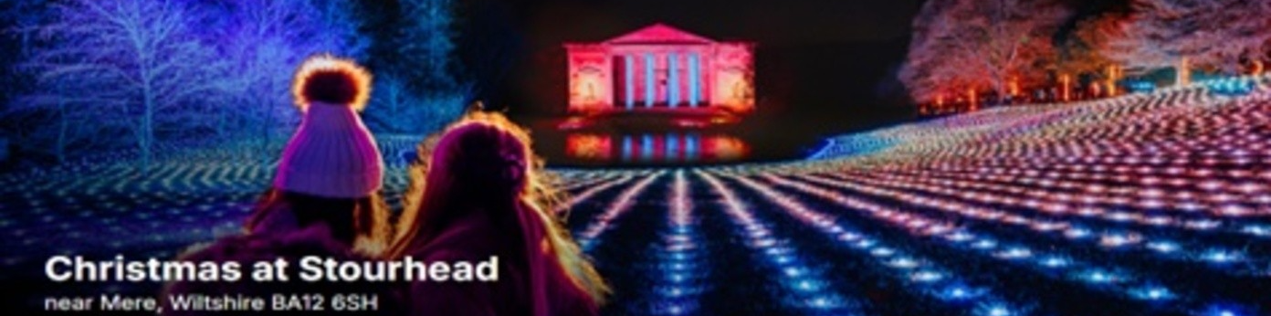
🎄 New Member Deal: Stourhead Christmas Lights 🎄
We’re spreading some festive cheer with an exclusive offer for members of the Bath and North East Somerset Social Club!
If you book tickets to the Stourhead Christmas Lights for any date between 27th November and 3rd January, we’ll refund £20 of your total ticket cost.
✨ How to Claim Your £20 Refund:
- Book your tickets via the official site: https://premier.ticketek.co.uk/shows/show.aspx?sh=CSTXMAS26
- Complete the Social Club form: Stourhead Christmas Lights 2026 – Fill in form
- Please email us:
-A copy of your invoice
-Your preferred bank details for the refund
We’ll process your £20 refund in January and send it directly to your nominated bank account.
📌 Important Notes:
- This offer is limited to one refund per member irrespective if multiple members attend via one booking (Maximum refund is £20)
- The first 20 will receive this offer, please feel free to check and we may close the offer early if this maximum is reached
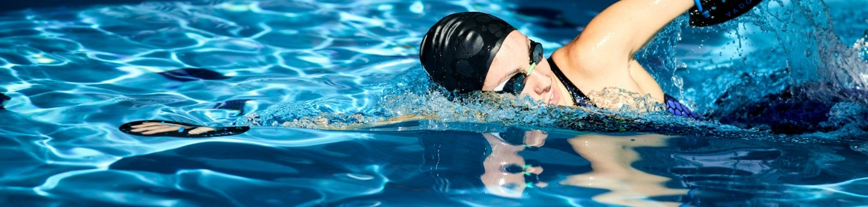
NEW BETTER Gym Membership

The Bath and North East Somerset Council Sports Social club has agreed another great offer with BETTER gyms. As a sports and social club member you can have a 12-month Better Health Corporate Partnership membership from 1st July 2026 at an up-front rate of £366/person/year.

Gym members can also nominate two friends and/or family members not living at the same address for the above price.

You will have full access to Bath Sport and Leisure, Odd Down Sports Ground and Keynsham Leisure Centre.

Membership Description:
- Access to gym floor, including cardio, functional & weights
- Access to fitness swimming pools (not leisure pool)
- Access to full fitness classes programme
- Access to spa pools, saunas and steam rooms
- Online library of 1500+ on demand fitness classes and workouts
- Online Health library of eBooks and eAudio resources
- 6 week support programme with certified instructors
- 7 Day advanced booking online or via the Better UK app
- Access to free WIFI in Better centres
- Up to 30% off other activities and services

Facility access subject to availability, refer to home centre and individual location page for facility listings. Health Suite excludes access to Spa Experience. Full terms and exclusions at www.better.org.uk/terms.

To take up this offer, please complete this form by the 31st May 2026:
BANES Social Club - Gym Membership, July 1st 2026 – Fill in form

Form and/or payments received after the deadline will not be processed. You must be a member of the social club for the entire year of the gym membership.

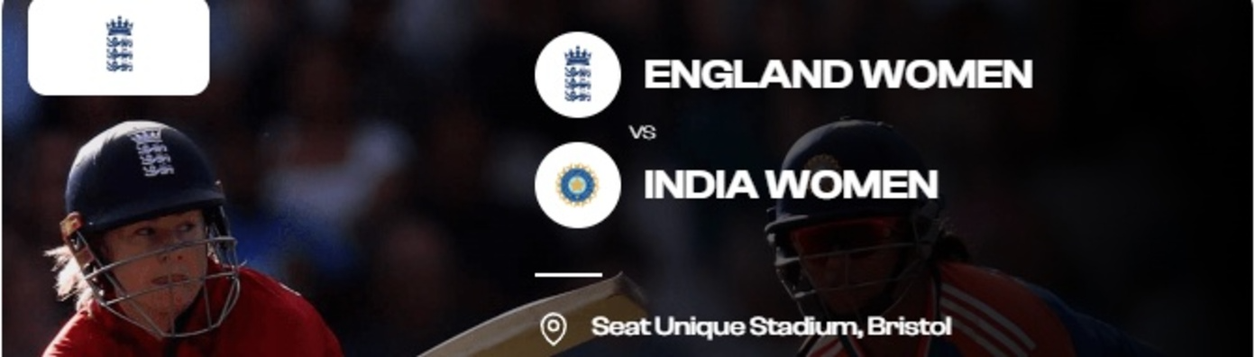
New Women's T20 International Cricket England Vs India
We’re spreading some summer cheer with an exclusive offer for members of the Bath and North East Somerset Social Club!
Date: Sat 30 May 2026, 14:30. Seat Unique Stadium, Bristol, WIT20
If you book tickets to this match we’ll refund £18 of your total ticket cost.
✨ How to Claim Your £18 Refund:
- Book your tickets via the official site: https://www.gloscricket.co.uk/tickets/
- Complete the social club form: Women's Cricket - England vs India T20 – Fill in form
- Please send us:
-A copy of your invoice
-Your preferred bank details for the refund
We’ll process your £18 refund in June and send it directly to your nominated bank account.
📌 Important Notes:
- This offer is limited to one refund per member irrespective if multiple members attend via one booking (Maximum refund is £18)
- The first 20 will receive this offer, please feel free to check and we may close the offer early if this maximum is reached

🎭 Theatre Shows 🎭
Booking forms available: https://www.bathnessocialclub.co.uk/theatre.php
Sleeping Beauty  Sunday 20th December 2026, 13:00  Bristol Hippodrome  Starring Craig Revel Horwood as the wicked Carabosse and Bristol panto favourite Andy Ford as Muddles!  Once upon a time in a faraway kingdom, Princess Aurora receives a birthday present from her wicked aunt Carabosse. A single prick of an enchanted spinning wheel places her under a cruel curse and sends her into a century of slumber!  Will true love endure? Will The Prince to break the spell? Who Come and find out in a panto packed with magic, music, comedy and dazzling special effects! | 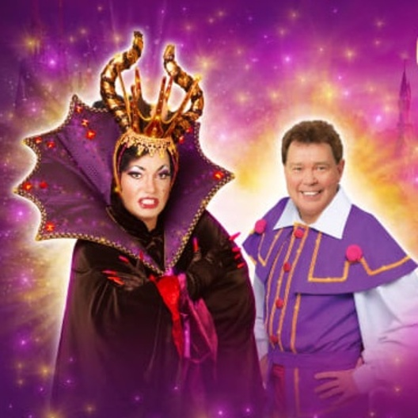  Members: £33  Non-Members First Guest: £33  Non-Members: £46  Children: £33  Closing Date: 22nd May 2026

----------------------------------------------------------------------------------------------------------------

NEW Beauty and the Beast  Saturday 2nd January 2027, 14:00  Theatre Royal Bath  Starring Jon Monie as the hilarious Louis La Plonk!  This glittering festive extravaganza promises breath-taking sets, glittering costumes and sensational choreography – all wrapped up in a magical story filled with laughter, romance and wonder. | 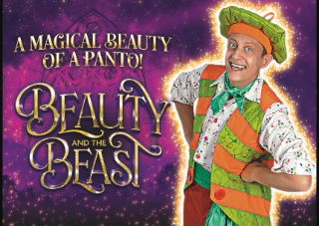  Members: £29  Non-Members First Guest: £29  Non-Members: £41  Children: £29  Closing Date: 22nd August 2026

🏷️ Local Offers 🏷️
Komedia Comedy Club  20% discount  On standard auditorium or balcony seats (not including Meal Deal options) for Komedia Comedy Club Saturdays using code: B&N4BDD at booking. This also includes free entry to The Big Disco or Motorcity afterwards!  22-23 Westgate St, Bath BA1 1EP  https://komediabath.co.uk/ | 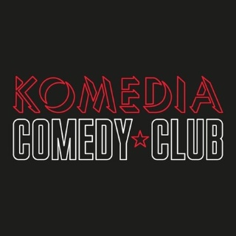

Little Theatre  25% discount  On annual membership  St Michael's Pl, Bath BA1 1SF  https://www.picturehouses.com/cinema/little-theatre-cinema | 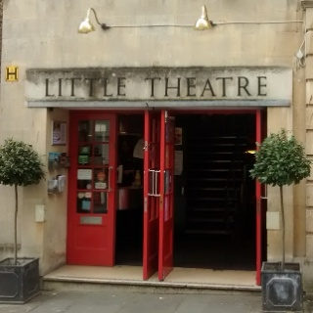

Bath Aqua Glass  15% discount  On in store items  14 Cheap Street / 15 Abbey Churchyard,  Bath, Somerset, BA1 1NA  https://www.bathaquaglass.com/ | 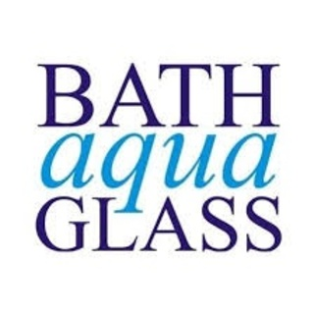

Boom Battle Bar Bath  15% discount  on all drinks and games in store  Kingsmead Leisure Complex,  5-10 James Street West, Bath BA1 2BX  boombattlebar.com | 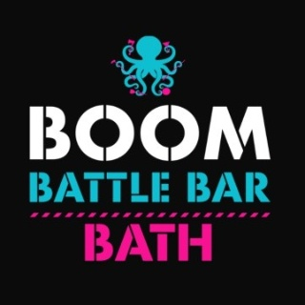

⛹️‍♂️ Sports ⛹️‍♂️
https://www.bathnessocialclub.co.uk/take-part-in-sports.php
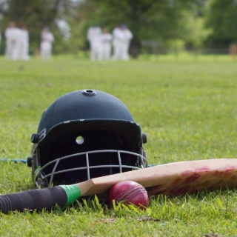 | Cricket Club  The Cricket Club organise matches over the summer and welcome players of all standards. The club plays 20-over matches in the evenings from the end of April to the beginning of August. It is a mixed-ability team that plays 'social' cricket in and around the city of Bath. They also try and organise pre-season cricket nets.  If you are interested in becoming a player or would like to umpire or score please email tom_deller@bathnes.gov.uk

 | Five-a-Side Football at Keynsham Leisure Centre  Come and join us for a friendly game of five-a-side football!  Played on Tuesdays from 12:00 - 13:00  £4 for members, £5.50 non-members.  To be added to the player list please email: robin_spalding@bathnes.gov.uk

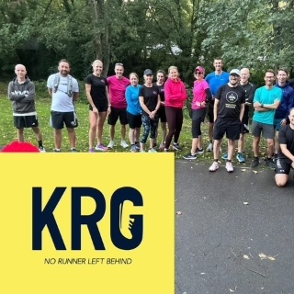 | NEW Keynsham Running Club  Meet us every Wednesday at 12:15pm outside Wild About Flowers for a relaxed and friendly 5km run around Keynsham with an optional brew at the end.  We welcome all abilities - whether you're new to running, returning after a break, or a seasoned runner. Our motto is “No runner left behind” and we mean it! And it’s free.

🏆 Social Club Committee 🏆
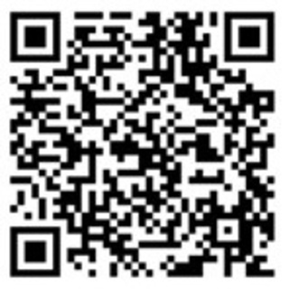 | Join the team!  We are run entirely by volunteers and we need more wonderful people to help us in planning and organising new events. Can you spare a couple of hours a month?  Please email us and we can invite you to our next meeting😊
Website: https://www.bathnessocialclub.co.uk/ Email: social_club@bathnes.gov.uk

