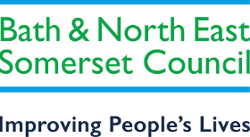
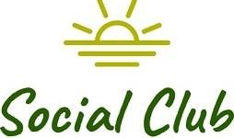
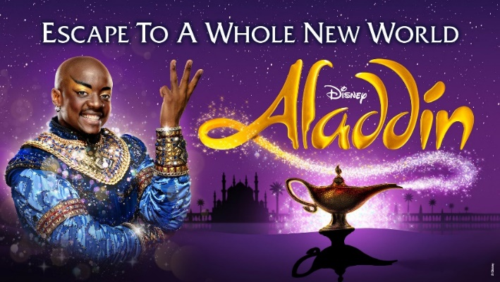
Bristol Hippodrome – Aladdin
Thursday 25th July – 19:30
We have 60 stalls seats reserved for Disney's Aladdin include all your favourite songs like One Jump, Friend Like Me and A Whole New World, as well as a few new songs for the stage, which all come together to tell this truly magical tale.
Disney Aladdin is recommended for a general audience. We recommend the production for ages 6 and up. Children under the age of 3 will not be admitted into the theatre. Under 16s must be supervised by an adult (18+) at all times.
To pay –
Email your booking form to social_club@bathnes.gov.uk and pay via –

Bank transfer: HSBC, sort code - 400944, account no - 20121282, account name -B&NES Social Club - Please use Aladdin as the reference, plus your initials.

OR
By post: PERSONAL/Bristol Hippodrome
Marie Bushby c/o Post Room,
Lewis House, Manvers Street, Bath, BA1 1JG

Cheque: payable to B&NES Social Club. The sports and social club are now charged 40p per cheque we pay in, please pay via bank transfer wherever possible.

If you pay by bank transfer please submit your booking form showing the tickets you want – and make the bank transfer. We will only contact you if there is a problem.

Please do not request specific seats – all seats are allocated on a ‘first come, first served’ basis and are dependent on what seats the Theatre is able to allocate.
Bookings are accepted on the strict understanding that the social club is unable to refund monies already paid to the hippodrome unless the Club is reimbursed by the Bristol Hippodrome.

Please provide up-to-date email address/telephone number as this makes it easier for us to contact you. All tickets will be sent near to the Showtime via email, if you would like your tickets posted please request this.

CLOSING DATE – 15th March 2024
E tickets are sent out a few weeks before the show.

Bristol Hippodrome – Aladdin

Thursday 25th July – 19:30
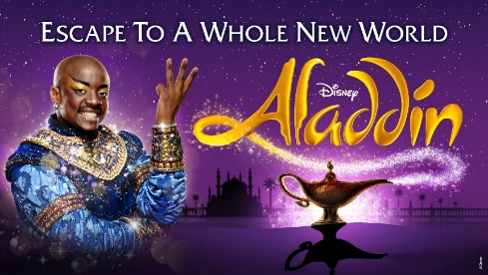
*Extended - CLOSING DATE NOW – 15th March 2024
I wish to reserve ___________ seats in total for Aladdin.
----------- Members @ £37.00 =
----------- Non-members @ £52.50 This is a group discount price; normal ticket price is £60.00. =
Disney Aladdin is recommended for a general audience. We recommend the production for ages 6 and up. Children under the age of 3 will not be admitted into the theatre. Under 16s must be supervised by an adult (18+) at all times.
Tick here to confirm you have paid via bank transfer ____________total
transferred________________ date transferred__________________?
Bank transfer: HSBC, sort code - 400944, account no - 20121282, account name -B&NES Social Club - Please use Aladdin as the reference plus your initials.
OR

Cheque for £_______________ included – Please note the sports and social club are now charged 40p per cheque we pay in, please pay via bank transfer wherever possible.

Name(s): …………… ……………………………………………………………………

Membership Number(s) …………………………………………………………………

(Name and Membership Number must be quoted for each member attending)

Home Address: (please complete - if we can’t send you your tickets by email)

………………………………………………………………………………………………

….……………………………………………………………………………………………

Tel: ………………………………… Email: ……………………………………………..

Bank transfer is our preferred payment method however if you are unable to pay this way, cheques should be made payable to ‘B&NES Social Club’ and sent in an envelope marked ‘Personal/Bristol Hippodrome’ to Marie Bushby, C/O Post Room, Lewis House, Manvers Street, Bath BA1 1JG. Please do not enclose cash.

E tickets are sent out a few weeks before the show.
CLOSING DATE – 15th March 2024

